That all is collected by removing the mistakes of the one paper file, hope it helpful…!

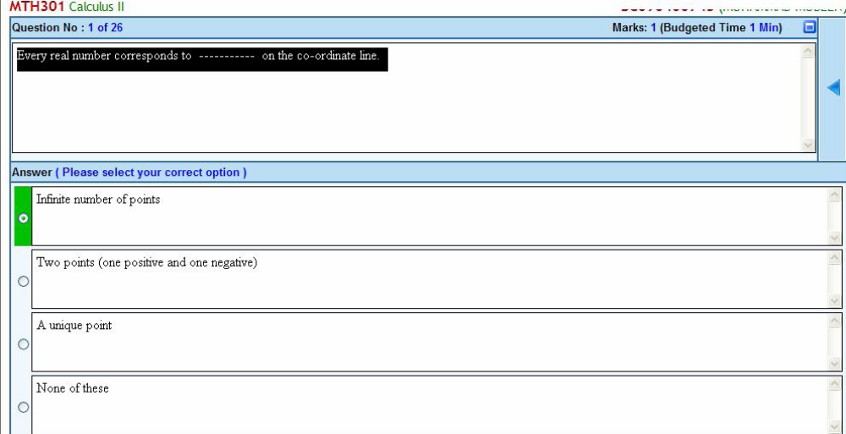
In that the answer is “unique point”

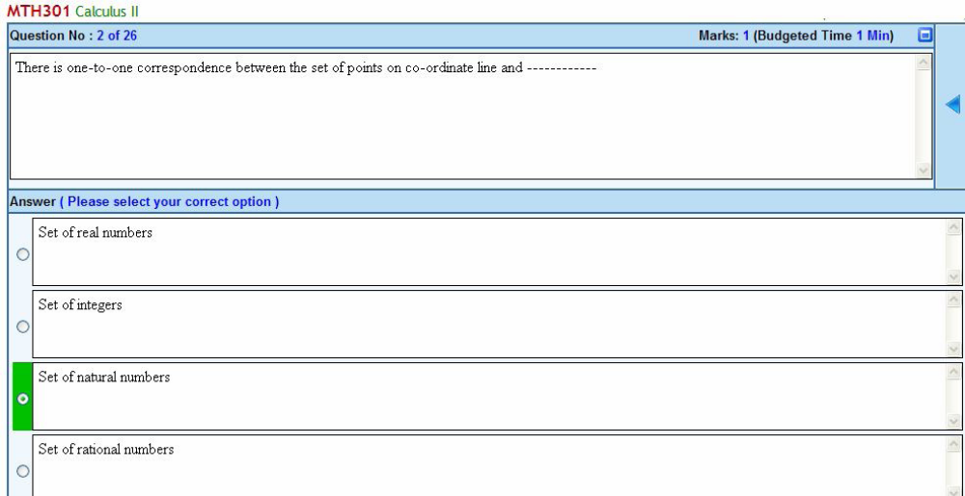
In that the correct answer is the “Set of Real Numbers”.

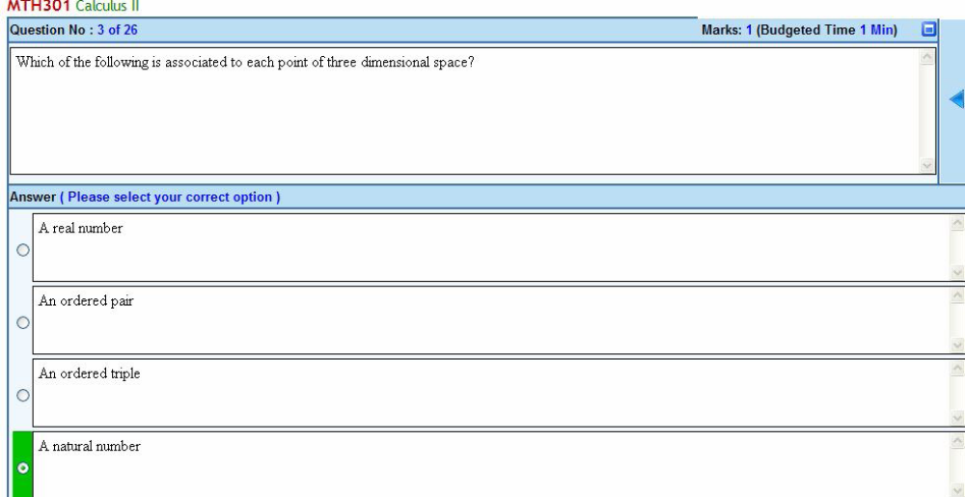
In this the exact answer is “an ordered triple”.

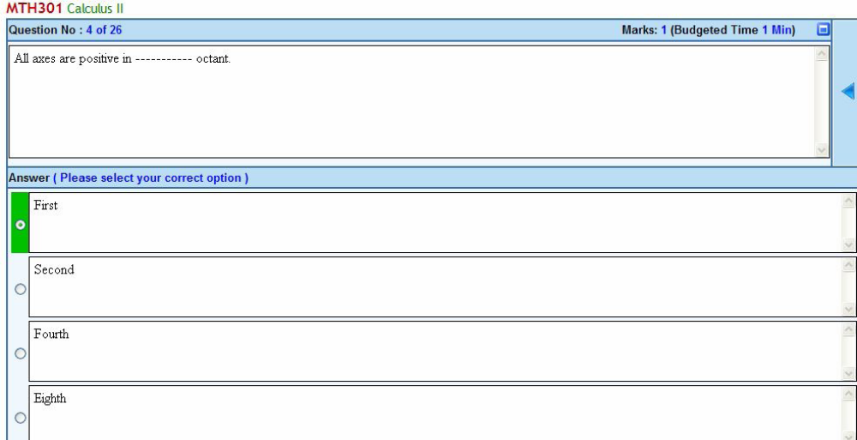
It’s right

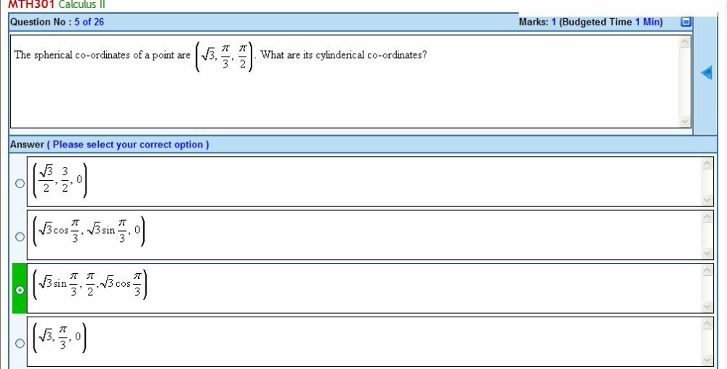
This one is also wrong as the answer is “4th one”.because the central point of spherical is pie/3 that should be same in cylindrical so, that’s only occur in last one…

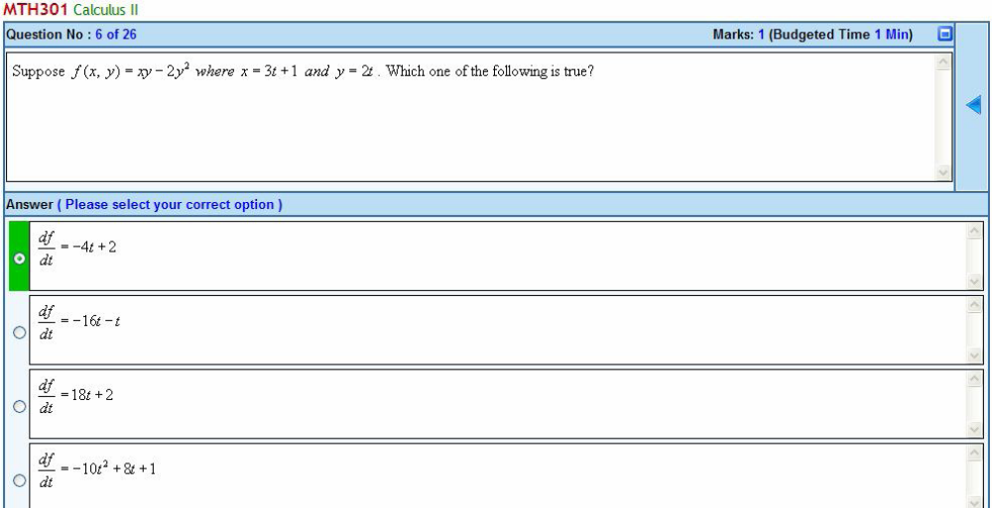
That’s right

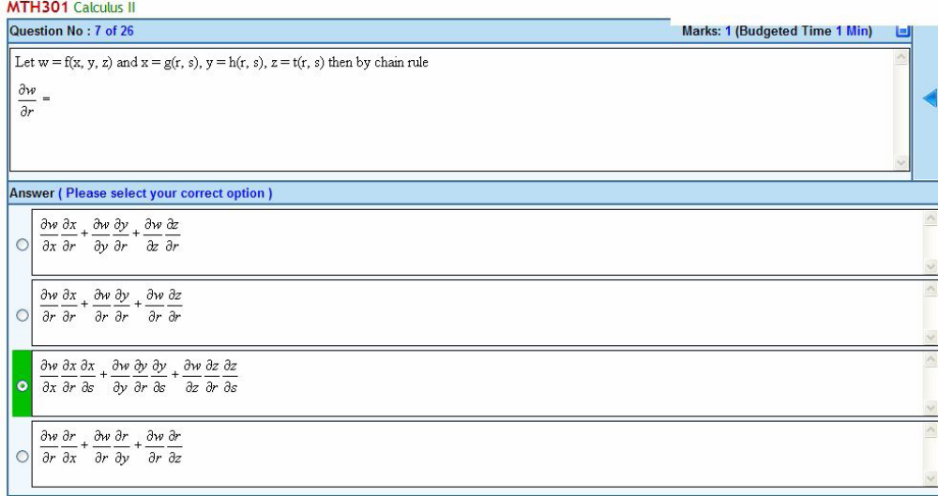
Here’s answer is the “2nd” one…!

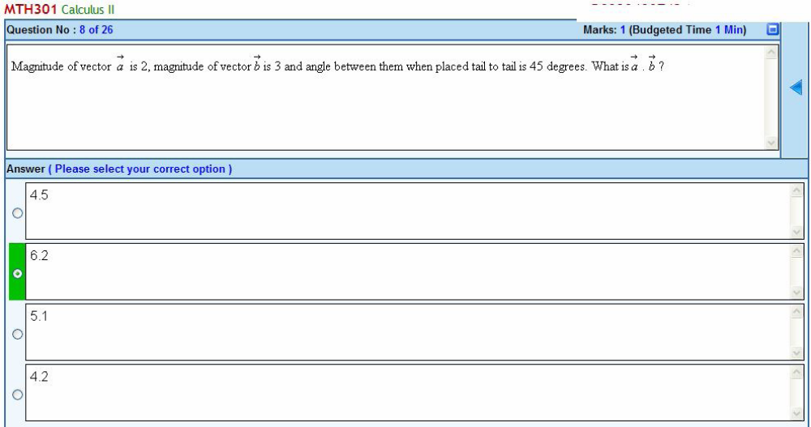
That can’t say exactly guys, its formula is following…!

a.b = |a||b| cosØ
Ø=angle between the vectors
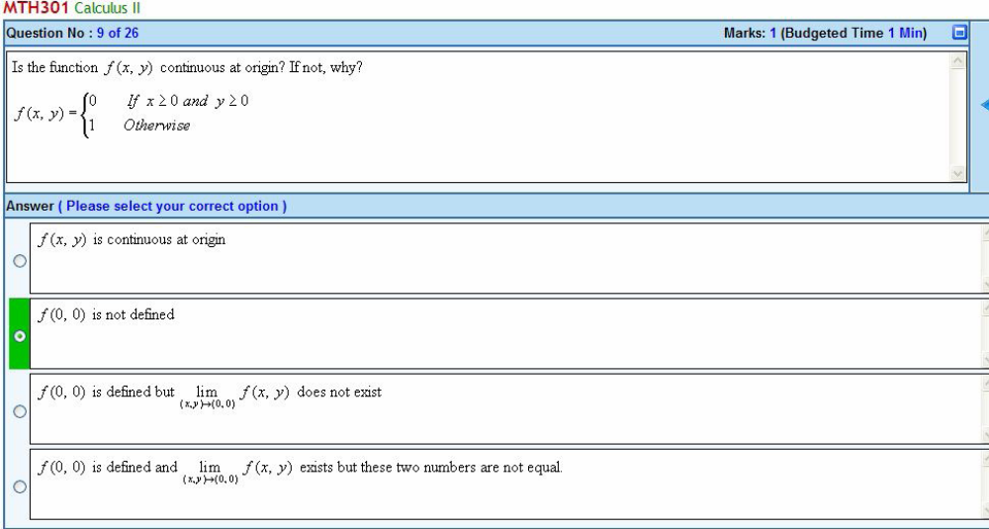
That’s correct answer…!

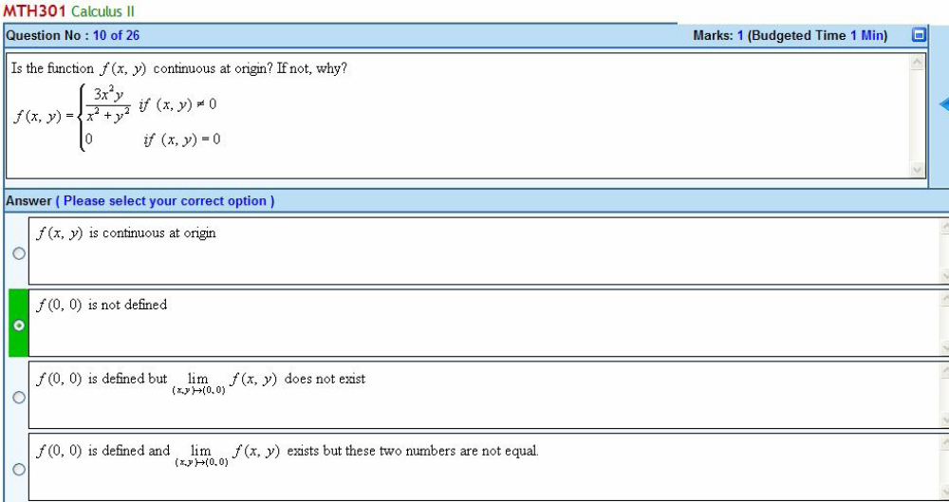
But that’s wrong the correc one is the 1st..

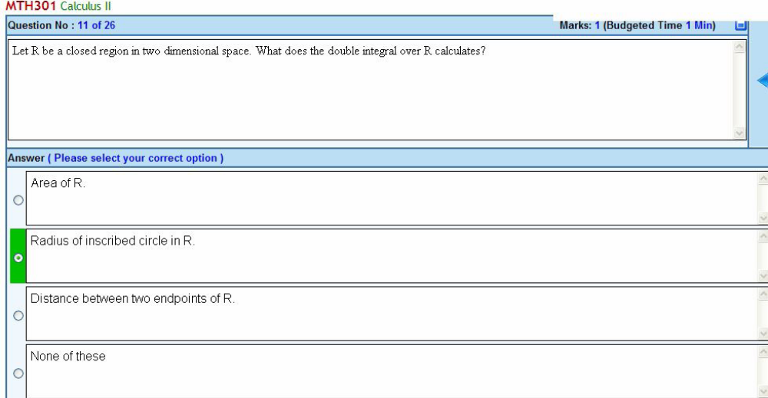
That’s the first answer, as that was been define in the lecture 22…!

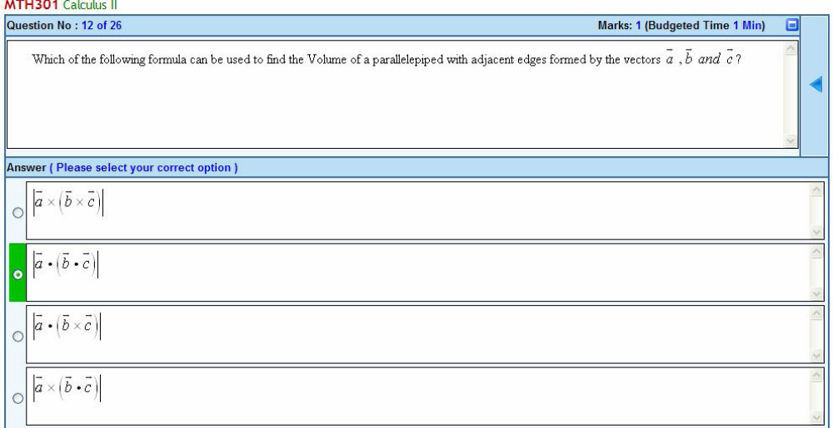
Here’s the answer is the last one, you can check that on the start of lecture 11th, handout…!

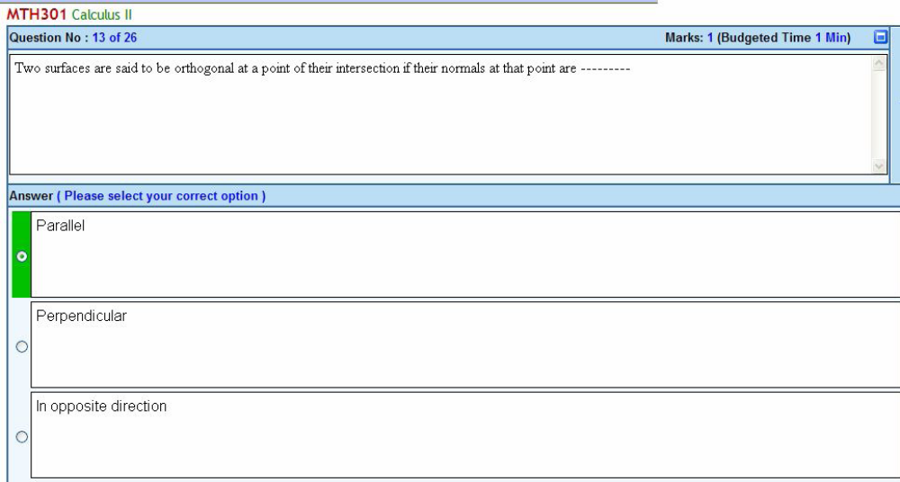
Its answer is the “perpendicular”…!

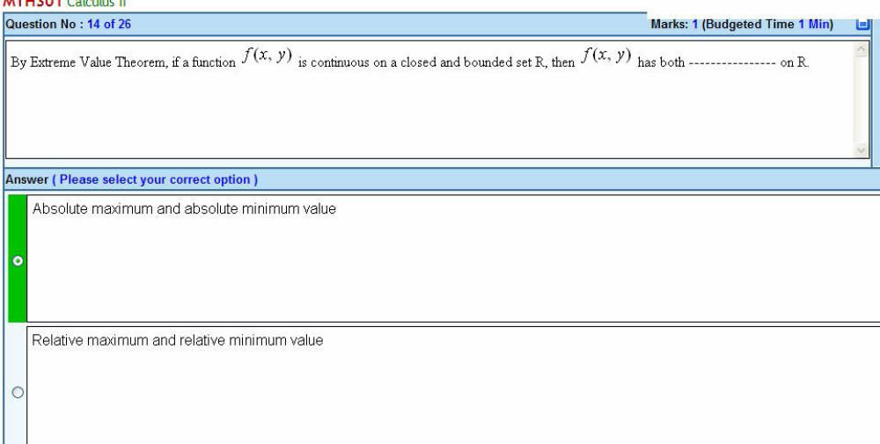
That’s right answer…!
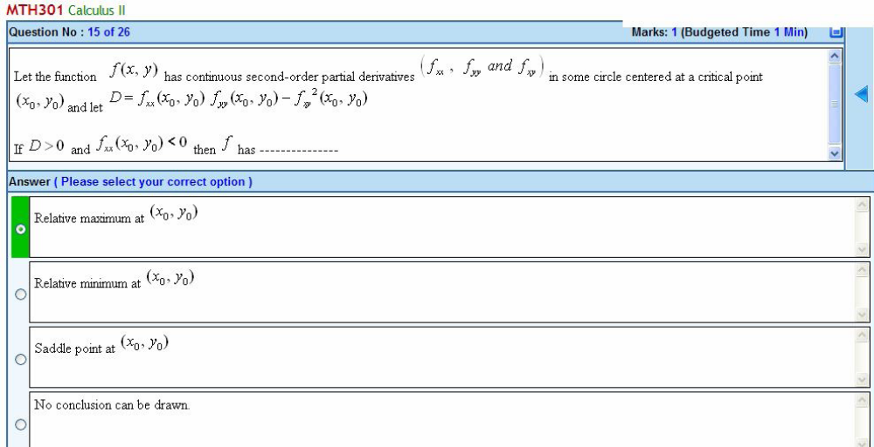
This is also right one..!

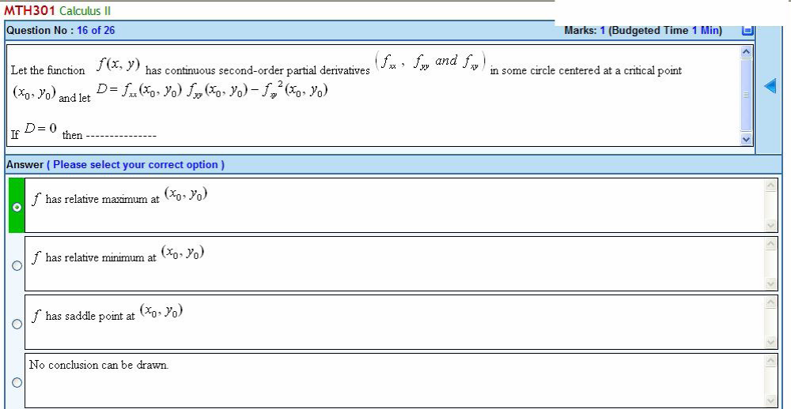
“No conclusion can be drawn” is the answere…!
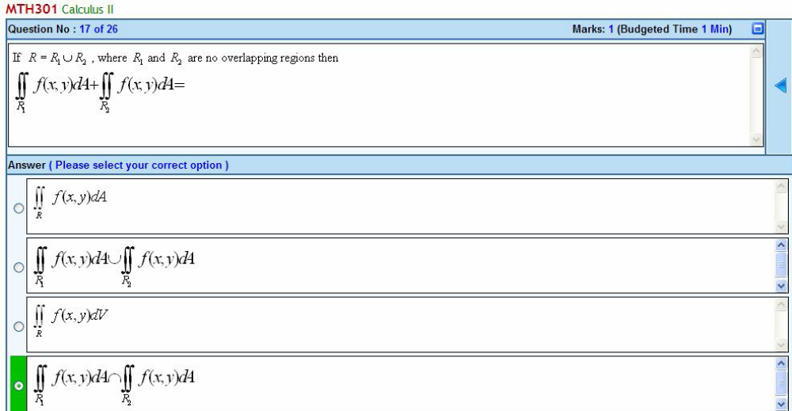
Its answer is the first one option…!

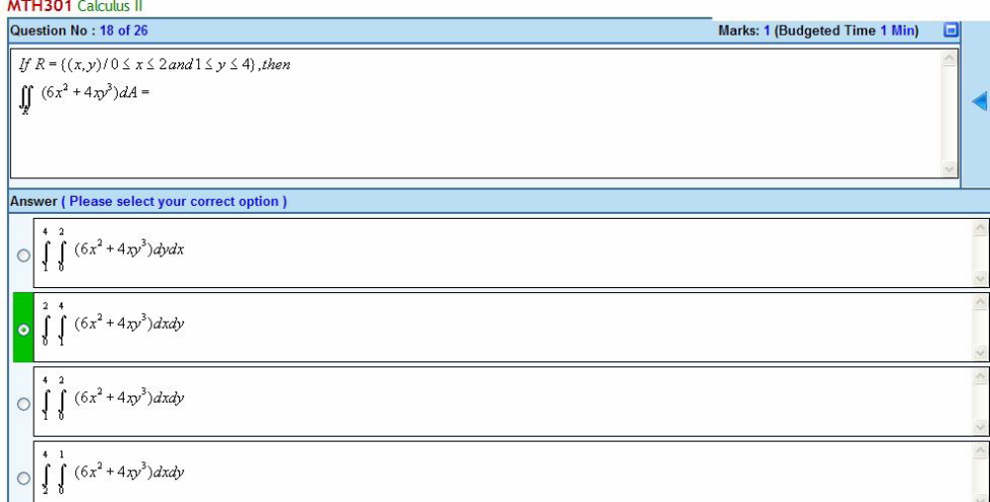
Its answer is the 3rd option guys..!
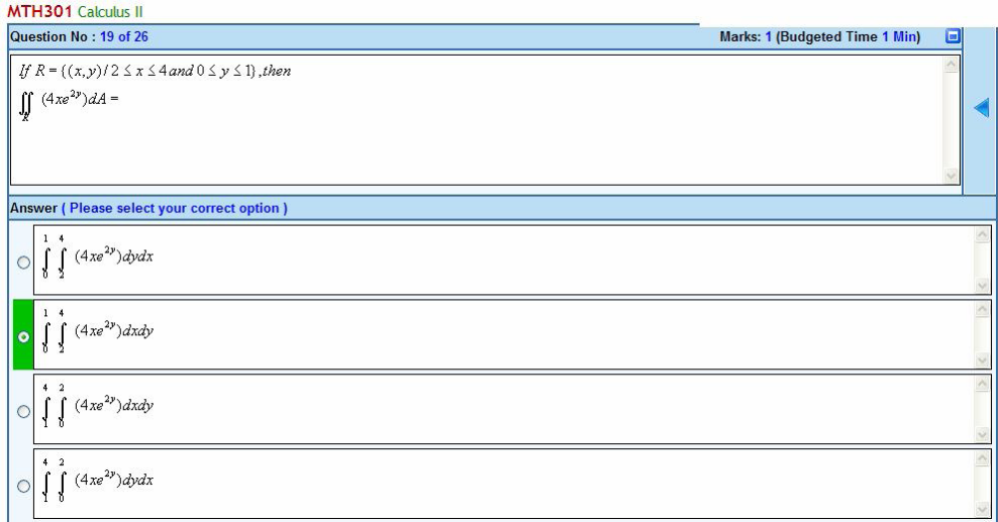
It’s right one…!

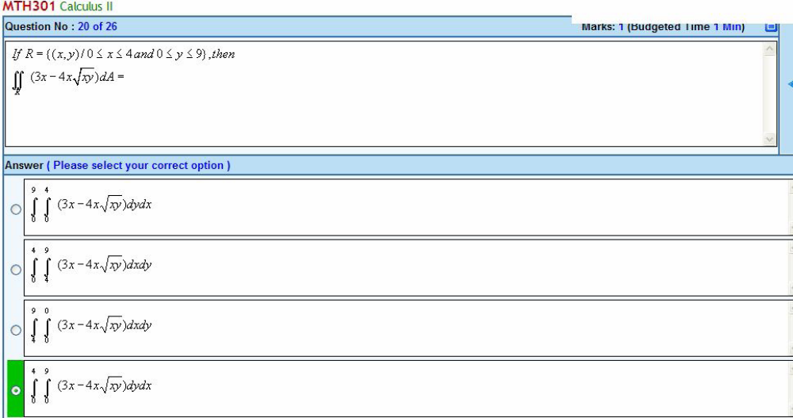
This one’s also right…

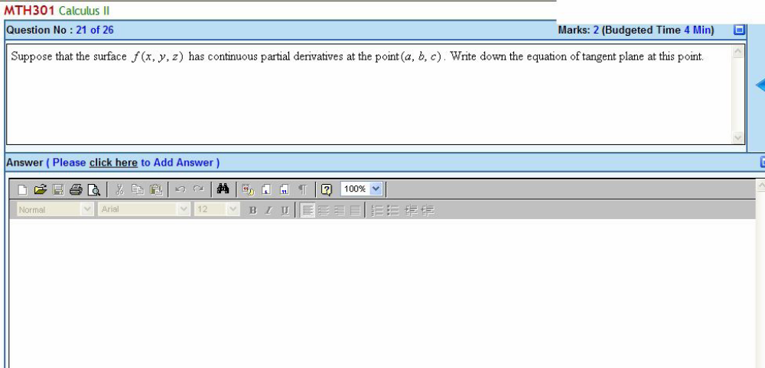

Its equation is

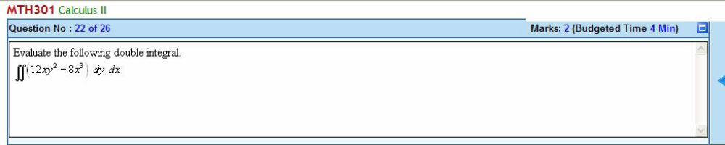

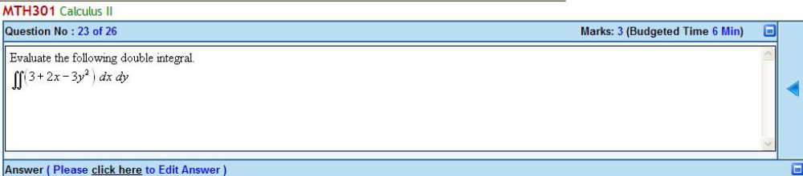
These both can be solve by the following example the me gonna paste…!

Evaluate the following double integral.
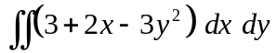
Solution:

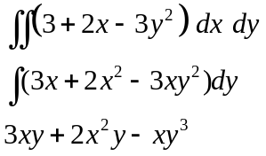

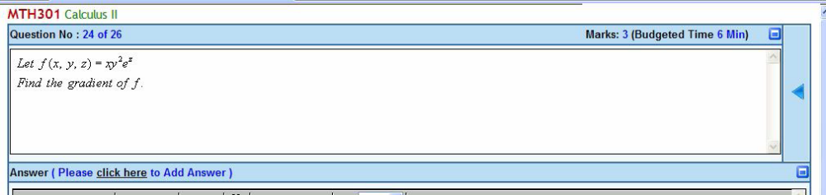I didn’t got this question dear’s…! :(

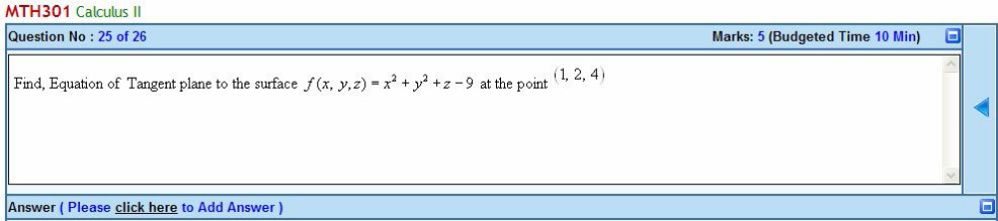
You can use the above tangent equation to sove this…!

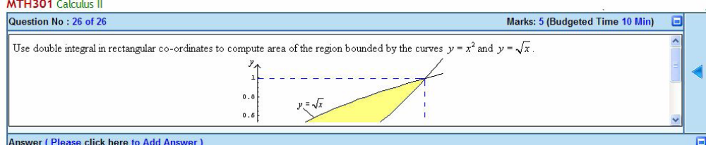
Its answer is the under mentioned…!

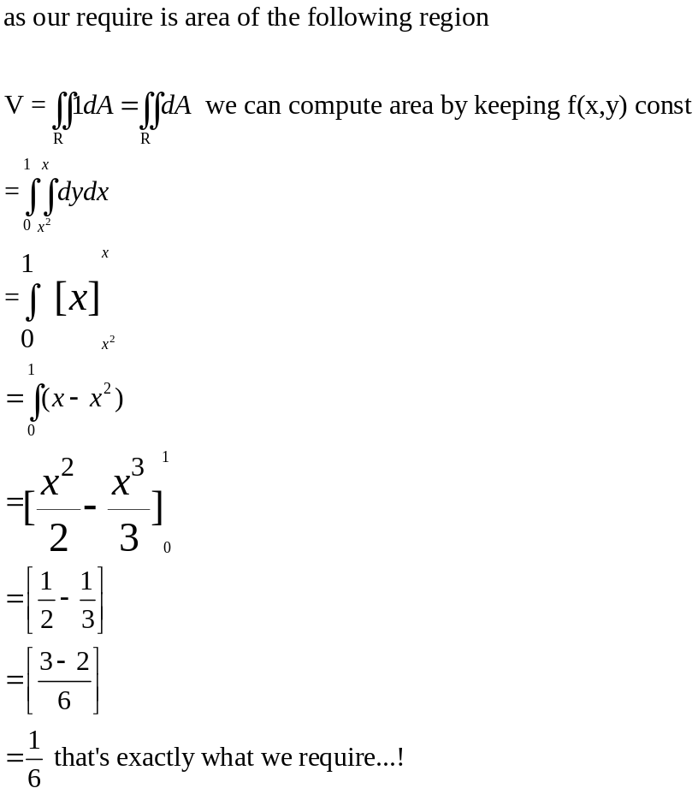

Jis bahi nay yeh create ki file us ko bhi aur muj(Zaheer Abbas) ko bhi jis nay uplode ki, dono ko apni doiaon main zaror yad rakhna. Allah Tiala hum sub ki her tarah say madad farmay. (Aameen)

